On the 22nd Oct 2023 our team arrived in the District of Bukwo and started work in Tulel and Kamet Sub counties.
We met a teams of the local leadership especially in Tulel.
Our local vet contact here is Collins Kwemoy, though we worked with many other vets there.
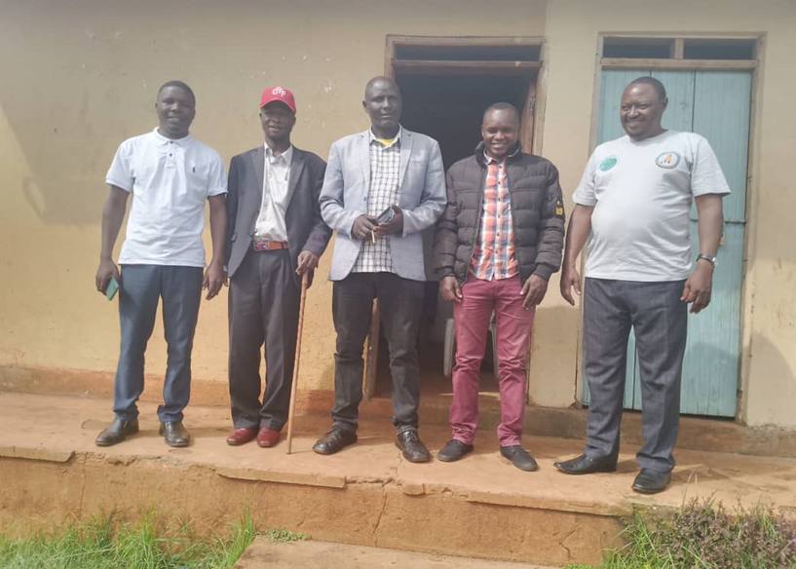

Like for many other Districts in Eastern Uganda, the donkeys welfare conditions are of great concern in this District. Bam Animal Clinics working with, partners we are continuously supporting the welfare of Donkeys in Bukwo. Just like in the other districts of Kapchorwa, Kween and Bukwo, Namisindwa, donkeys here have challenges of over working, wounds as a result of poor or no use of genuine saddles. Majority have wounds at the backs of their tails and on their backs.
The team is engaged in training locals, including school children about primarily how to make humane sisal sacks’ Saddles that are easy to make and use, to reduce on the burden of using inappropriate Saddle-like, improvised materials which end up causing more harm to the Donkeys.
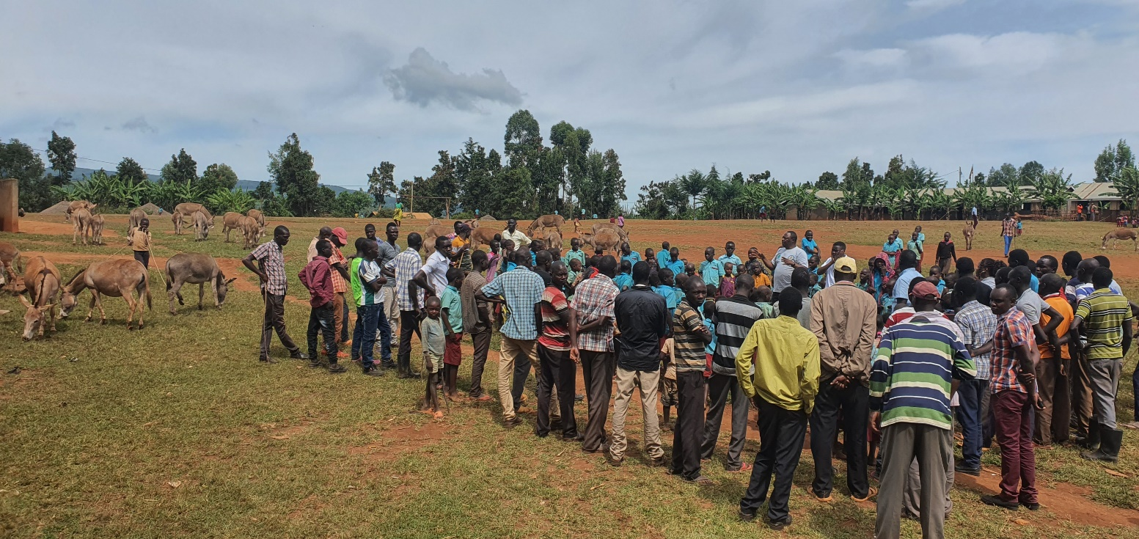

Wounds inflicted on the backs of donkeys as a result of limited use of Saddles sometimes the saddles are of poor quality even when used. If carefully looked the base of the tails on most donkeys, they have severe wounds due to bad harnesses. These donkeys will be treated free of charges curtsey of Animal-kind international supportand farmers will be advised to rest the Donkey for sometime then made to work again when wounds have reduced
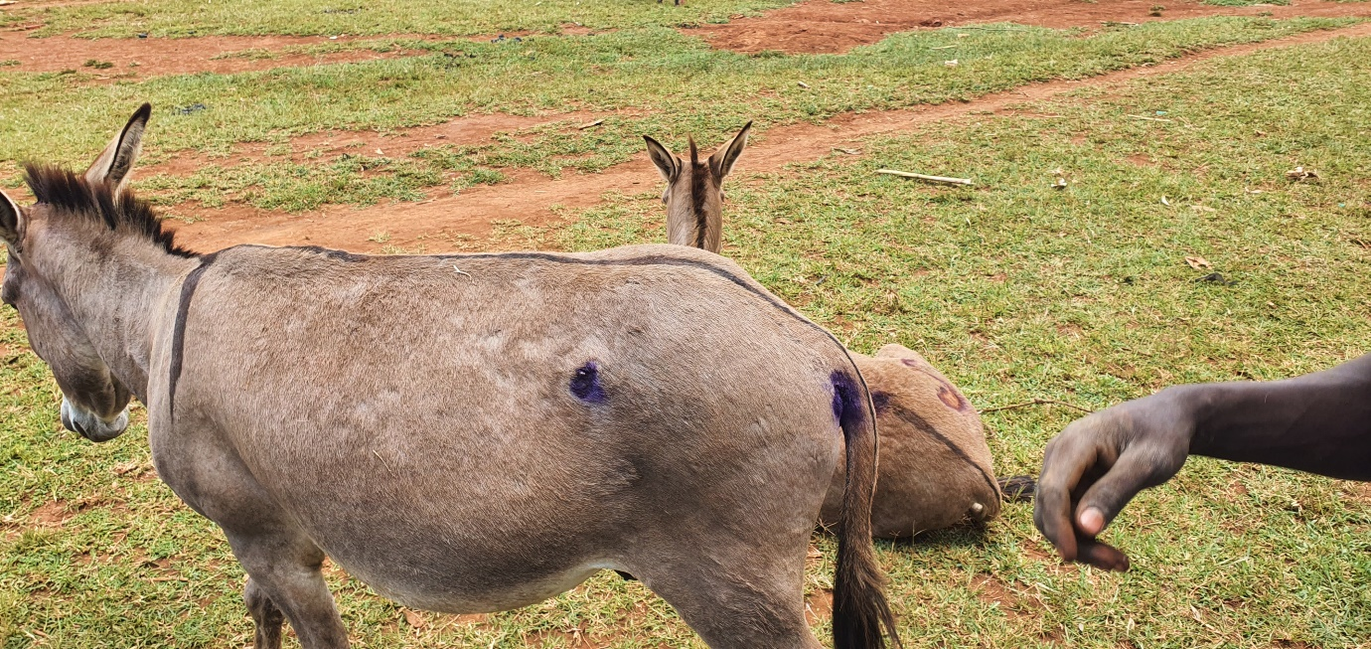
Donkeys suffer to get a little grass to feed on because of constant draughts. In some places @Bam animal clinics provide nutritional supplements to support these donkeys.
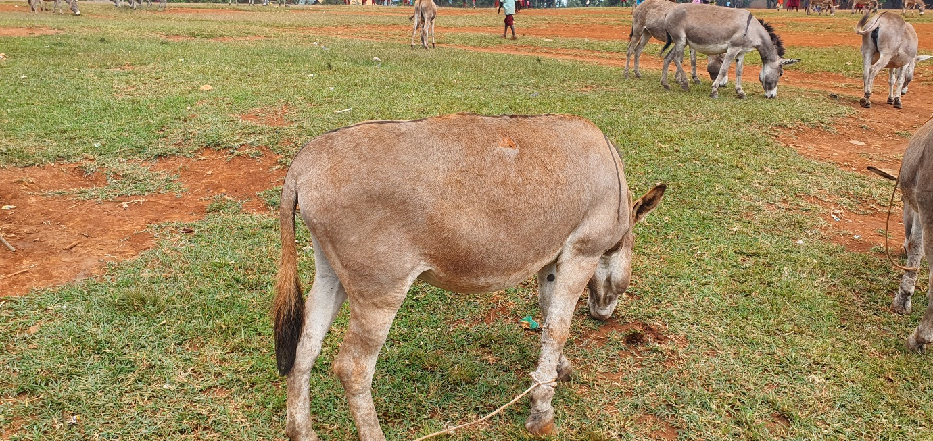

The donkey could be a very useful animal in most areas of Uganda as a domestic source of draft power, for example helping women to collect water and firewood, if its health and dietary requirements were met

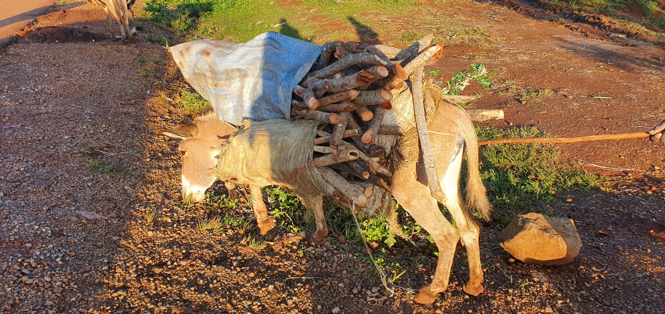

A herd of donkeys being taken for work, we met these on the way to Tulel subcounty. Donkeys are not well fed seen from their body score indices, the donkeys are over worked especially during harvesting seasons.
There is quite a lot needed to educate handlers to observe basic welfare issues to reduce on the suffering.

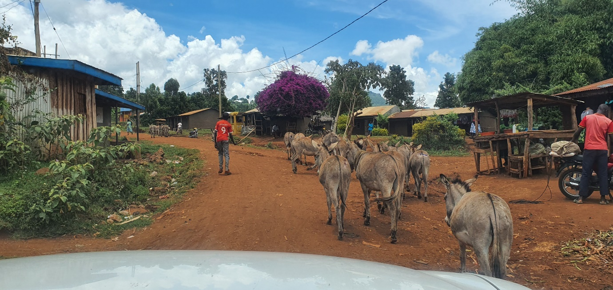

Humane sisal saddles are a great way to keep donkeys free from injuries. They are easy to make and use, are made from readily available materials, they are durable, and they help prevent injuries, especially on those important areas; behind the donkey's tail and back. They provide good cushioning against abrasions and other wounds when donkeys are carrying loads of wood, produce, and water.
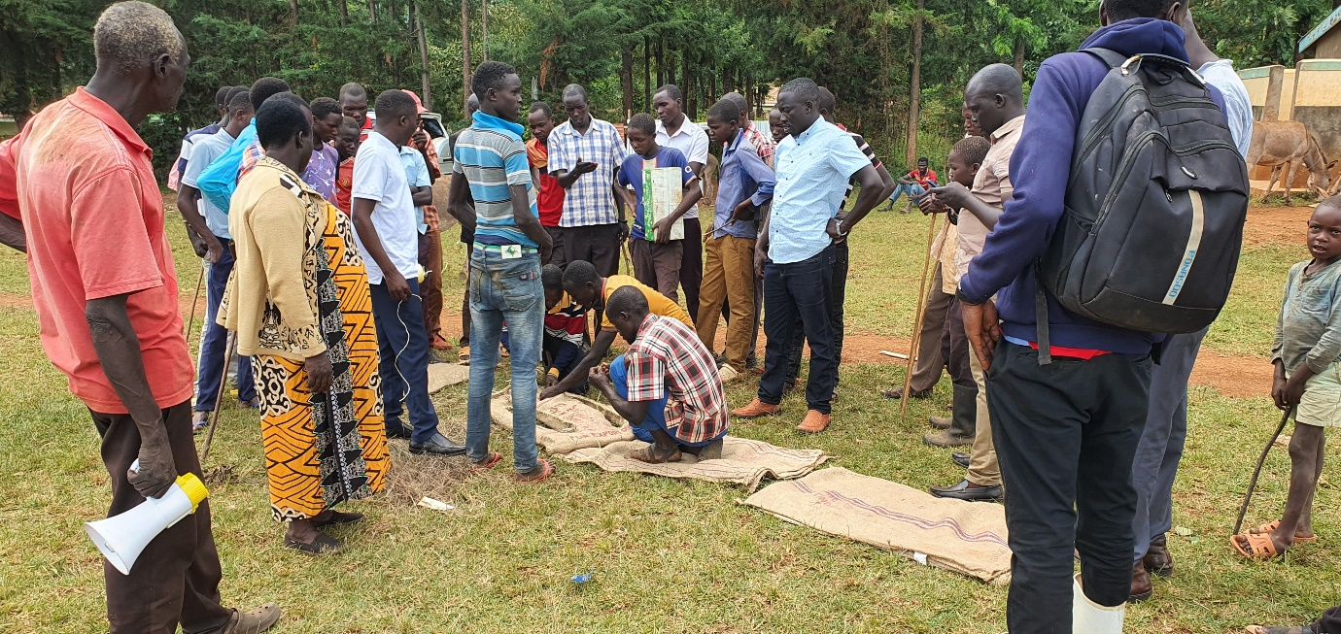

Like for many previous clinics, we had an overwhelming turnout, as seen from these pictures in Tulel sub-county in Bukwo District. Every donkey owner receives the full animal welfare package: sisal saddle training and a pair sisal saddle, diagnosis and treatment of their donkeys all for free curtsey of our AKI supporters.

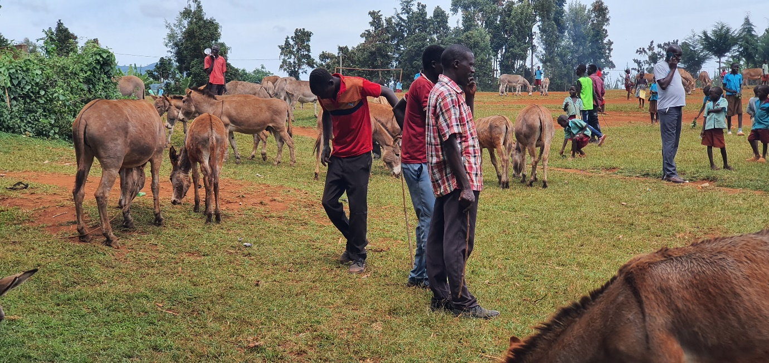

Our main activities include;
Ensuring that the donkey using communities understand the importance of providing good care of their donkeys, including good nutrition, water, shelter, rest, and preventive health care.
Advises people of work limits and maximum load a donkey can carry.
Instructs on how to construct simple shelters for their donkeys.
Emphasizes construction of fences to keep donkeys safe at night and community policing to minimize theft of donkeys.
Promotes the use of humane saddles.
Provides free vet care at the clinic including diagnosis and treatments of animals free of charge.
And finally, to encourage communities that rely on donkeys to place greater value on their donkeys.

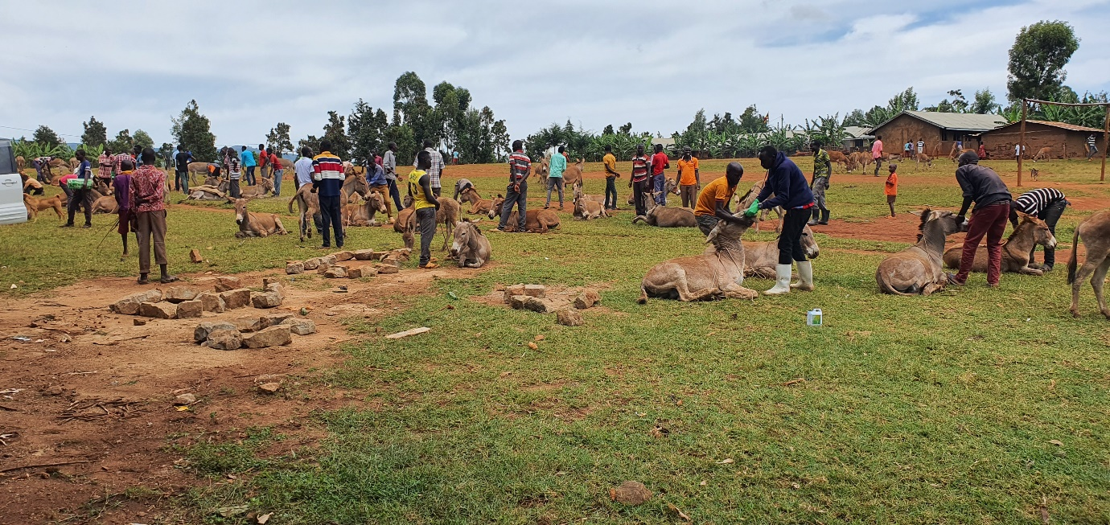

Donkey had a melanoma and we did simple surgery to clear the lesion.
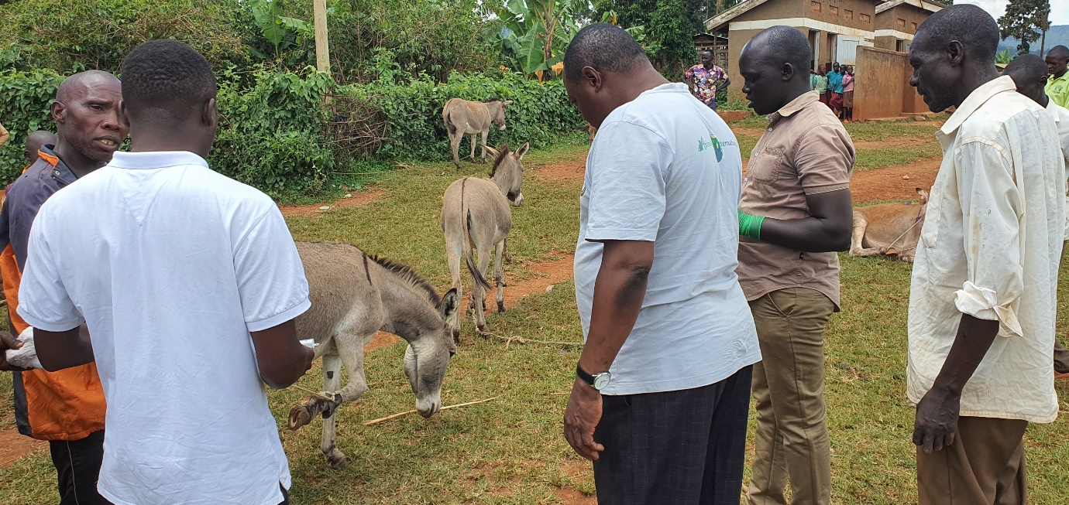
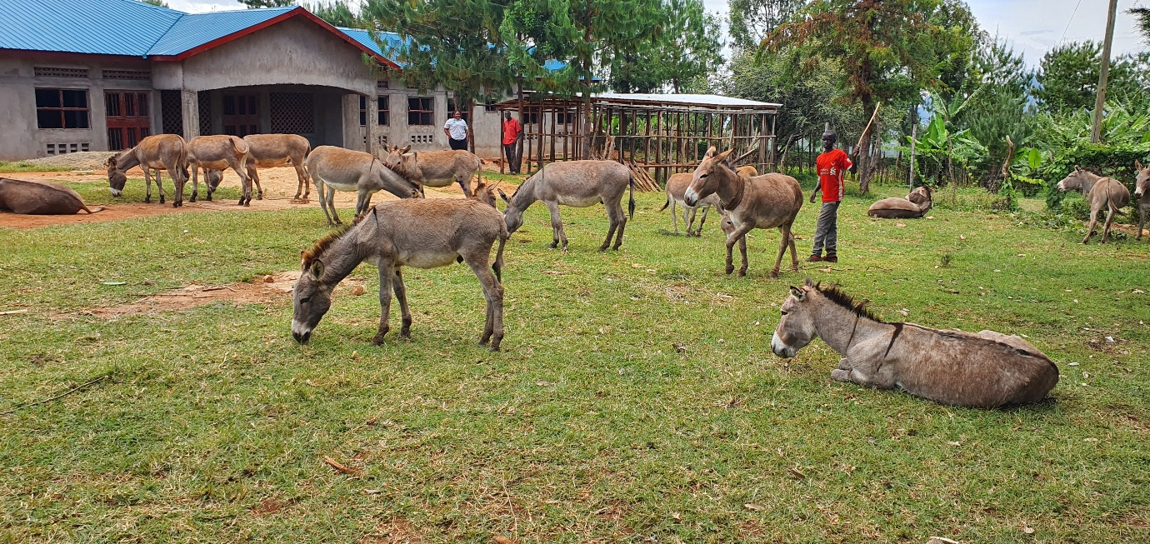

Donkey sported with an injured eye. Was worked on and high prospects for recovery.
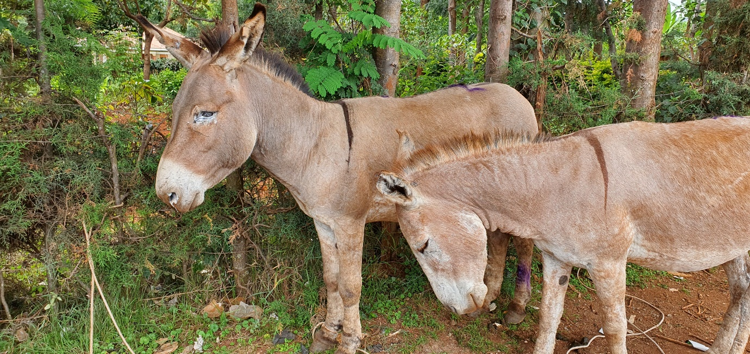
Roadside intervention, to treat injured Donkeys and give humane ideas.
